Process Definition Document (PDD)

*Process Name: Send_confirmation*

Table of Contents

**Introduction** **1**

Purpose of the Document 1

Objectives 1

Process Key Contact 1

Minimum Prerequisites for Automation 1

**As-Is Process Description** **2**

Process Overview 2

Applications used in the Process 3

As-Is Process Map 3

**To-Be Process Description** **3**

Detailed Process Map 3

Robot Type 4

Business Exceptions Handling 4

Known Exceptions 4

Unknown Exceptions 4

System Exceptions Handling 4

**Other Observations** **5**

**Additional sources of process documentation** **5**



# Introduction

## Purpose of the Document

The Process Definition Document outlines the business process chosen for automation using UiPath Robotic Process Automation (RPA) technology.

The document describes the sequence of steps performed as part of the business process, the conditions and rules of the process prior to automation and how they are envisioned to work after automating it, partly or entirely. This specifications document serves as a base for developers, providing them with the details required for applying robotic process automation to the selected business process.

## Objectives

The business objectives and benefits expected by the Business Process Owner after automation of the selected business process are:

* Automate the process of sending out confirmations to customers of completed transactions.
* Savings/Benefits: 1 FTE

## Process Key Contact

The specifications document includes concise and complete requirements of the business process and it is built based on the inputs provided by the process Subject Matter Expert (SME)/ Process Owner.

The Process Owner is expected to review it and provide signoff for accuracy and completion of the steps, context, impact and a set of process exceptions. The details are to be included in the table below.

|  |  |  |  |
| --- | --- | --- | --- |
| Role | Name | Contact Details  (email & phone number) | Notes |
| Process Owner | Kamal | [kamal@kamal.com](mailto:kamal@kamal.com)  123-4567-8910 |  |
| Business Analyst | Kamal | [kamal@kamal.com](mailto:kamal@kamal.com)  123-4567-8910 |  |

## Minimum Prerequisites for Automation

|  |  |
| --- | --- |
| Met (Y/N) | Prerequisites |
| Y | A filled in and completed Process Definition Document |
| Y | Closure of any open process questions |
| Y | Environment set up |
| Y | Test Data to support development and testing |
| Y | User access and creation of user accounts (licenses, permissions, restriction to create accounts for robots) |

# As-Is Process Description

## Process Overview

General information about the process selected for RPA prior to automation.

|  |  |  |
| --- | --- | --- |
| # | Item | Description |
| 1 | Process Full Name | Send Transaction confirmation |
| 2 | Process Area | Finance |
| 3 | Department | Lending |
| 4 | Process Short Description  (operation, activity, outcome) | User go to a folder in hard drive, look for folder with current date, for each of the excel files name matching “date-caseid-amount” example 20210316-xyz123-300.xlsx; open the file, convert the “customer copy” worksheet to pdf, pick up the customer email from the file and send out the email using outlook with pdf as an attachment. Repeat the steps for all the files processed today. |
| 5 | Role(s) required for performing the process | Lending clerk |
| 6 | Process schedule and frequency | After 1 pm every weekday |
| 7 | # of items processed /reference period | 1 item/ 5 minutes |
| 8 | Process execution time | 2 hours |
| 9 | Peak period(s) | Month End |
| 10 | Transaction Volume During Peak period | 150 |
| 11 | Total # of FTEs supporting this activity | 1 |
| 12 | Expected increase of volume in the next reference period | 5% increase per annum |
| 13 | Level of exception rate | Less than 5% |
| 14 | Input data | Structured |
| 15 | Output data | N/A |

*Add more rows to the table to include relevant data for the automation process. No fields should be left empty. Use “n/a” for the items that don't apply to the selected business process.

## Applications used in the Process

The table includes a comprehensive list of all the applications that are used as part of the process to be automated to perform the given steps in the flow.

|  |  |  |  |  |  |
| --- | --- | --- | --- | --- | --- |
| # | Application Name & Version | System Language | Thin/Thick Client | Environment/ Access Method | Comments |
| 1 | Microsoft Excel 2016 | English | Thick | IT | NA |
| 2 | Microsoft Outlook 2016 | English | Thick | IT | NA |
| 3 |  |  |  |  |  |

*Add more rows to the table to include the complete list of applications.

## As-Is Process Map

**High Level As-Is Process Map:** This chapter depicts the As-Is business process at a High Level to enable developers to have a high-level understanding of the current process.

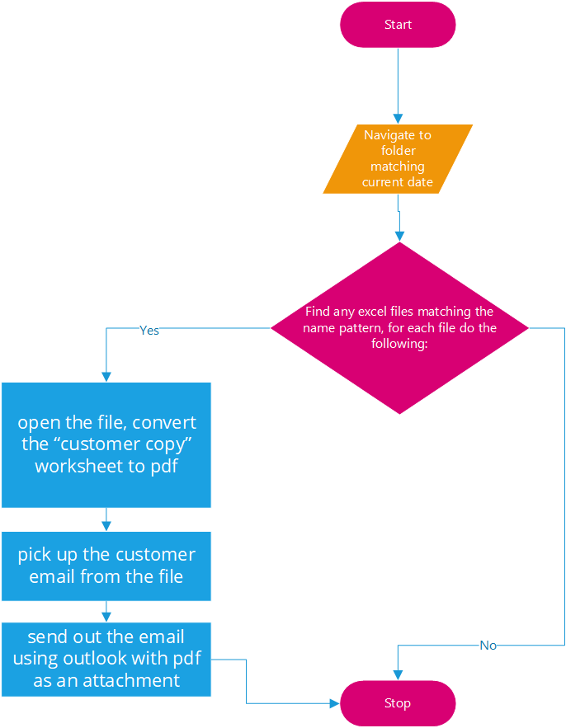

**Detailed Process Map:** This chapter depicts the As-Is business process at a detailed view to enable process owners to document their process

|  |  |  |  |
| --- | --- | --- | --- |
| # | Step Action/Description | Screenshot | Remarks |
| 1 | Look for folder with current date |  | Assuming today is May 6, 2021 |
| 2 | For each of the excel files name matching “date-caseid-amount” example 20210506-xyz123-200.xlsx, open the file |  |  |
| 3. | Convert the “customer copy” worksheet to pdf |  |  |
| 4. | Pickup email address from the worksheet “main sheet” |  |  |
| 5. | Send out the email using outlook with pdf as an attachment |  |  |
|  |  |  |  |

# To-Be Process Description

## Detailed Process Map

**High Level To-Be Process Map:** This chapter depicts the To-Be automation process at a High Level to enable developers/COE to have a high-level understanding of the to be developed process.



**Detailed Process Map:** This chapter depicts the To-Be automation process at a detailed view to enable developers/COE to see the workflows involved in the RPA solution

|  |  |  |  |  |  |
| --- | --- | --- | --- | --- | --- |
| **Workflow Name** | **Description** | **Pre-condition** | **Post-action** | **Arguments** | **Notes** |
| UploadtoQueue | Workflow to navigate to folder matching current date (today) and get the files matching the criteria. Upload the full file path including file name to Orchestrator queue. | A folder name matching current-date. | Start excel and outlook applications. | NA | Orchestrator Queue: file_Processing |
| Main | Main workflow used to trigger other workflows in the capstone RPA project. 1.Bot look up a path on hard drisk, look for a folder named as current date (YYYYMMDD)  2. Loop through excel files matching a particular name pattern.  -convert one of the worksheet " customer copy" in the excel file to pdf.  -Pick email address from another excel worksheet "main file" to send out emails with pdf as attachment. | All other workflows should be available and properly invoked. | N/A, if everything goes without an error, automation ends. | NA | NA |
| Before start and after run | This workflow is used to Shut down applications; outlook and excel, before the main automation begins , to avoid opening mutiple instances of an appliaction. The workflow is also used at the end of the automation to close applications involved. | N/A | Excel and outlook is closed. | NA | NA |
| getTransaction | Get items from the orchestrator Queue and then invoke convertTodf and get_email_address workflows. | Should have some items in the queue for perfrmer bot. | Set transaction status of queue item to successful | NA | NA |
| ConvertToPdf | Workflow converts the excel worksheet to pdf | Orchestrator queue shoud have transaction items for processing | Pdf file saved in the same location as the originating excel file | in_FileName in_CurrentDate in_PdfFileName | NA |
| get_email_address | Sends out the email wth pdf file as a attachment. | Should have some pdf files in the folder | Emails sent out | in_FileNameEmail in_CurrentDate in_PdfFileName | NA |

## Robot Type

|  |  |  |  |  |
| --- | --- | --- | --- | --- |
| # | Attended | Unattended | Trigger | Comments |
| 1 | 0 | 1 | 1pm weekday, and/or user trigger the run |  |

## Business Exceptions Handling

The Business Process Owner and Business Analysts are expected to document below all the business exceptions identified in the automation process. These can be classified as:

### Known Exceptions

The table below reflects all the business process exceptions encountered during the process evaluation and documentation. These are known exceptions that occurred before. For each of these exceptions, define a corresponding expected action that the robot should complete if it encounters the exception.

|  |  |  |  |  |
| --- | --- | --- | --- | --- |
| BE # | Exception Name | Step | Parameters | Action to be Taken |
| 1 | No valid files found in the folder. | 2 | No files found in the folder for current date | Send email to process owner and end the automation. |
|  |  |  |  |  |
|  |  |  |  |  |

### Unknown Exceptions

For all other unanticipated or unknown business (process) exceptions, the robot should:

* Log the event, send an email to process owner and shut down the automation.

## System Exceptions Handling

A comprehensive list of all errors, warnings or notifications should be consolidated here with the description and action to be taken, for each, by the robot.

Errors identified in the automation process can be classified as:

|  |  |  |  |  |
| --- | --- | --- | --- | --- |
| SE # | Exception Name | Step | Parameters | Action to be Taken |
| 1 | Unexpected error | Can occur at any time, not anticipated | Main.xaml | Email to process owner, end the automation |
| 2 | Unexpected system exception | Can occur during upload to orchestrator queue | UploadToQueue.xaml | Email to process owner, end the automation |
|  |  |  |  |  |

# Other Observations

Include below any other relevant observations you consider needed to be documented here.

# Additional sources of process documentation